
WHOLE-TRILOGY GUIDE
The Ember Wren Mysteries
Trilogy Discussion & Teaching Guide
Books One to Three · Ages 8–12 · Years 5–7
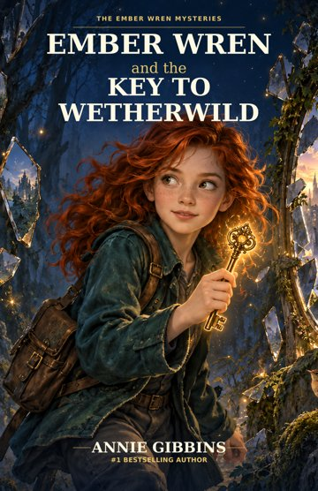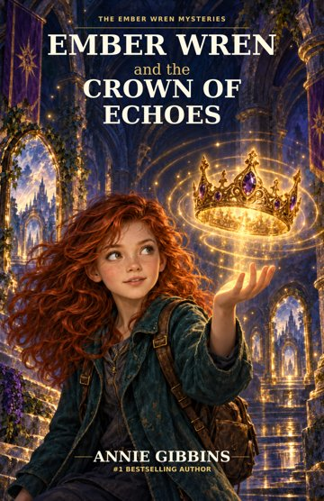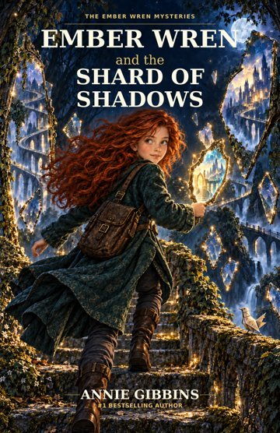
WHOLE-SERIES FOCUS
How Ember learns to stay curious without confusing knowledge with authority, memory with permanence, or possibility with destiny.

Annie Gibbins · Satinbird Press · satinbirdpress.com

How to Use This Guide
This guide is designed for readers, teachers, librarians and book clubs who have completed all three Ember Wren novels. It brings the trilogy together without replacing the individual Teacher Resource Packs or Book Club Discussion Guides.
Use it for a final series discussion, comparative English unit, extension project, literature-circle synthesis, library event or book-club celebration.
SPOILER NOTE
This guide contains major spoilers for all three books. Use it only after readers have finished the trilogy.

Trilogy at a Glance
Book | Central magical system | Ember's temptation | Deeper question
Book One: The Key to Wetherwild | The green and silver keys, the Keeper system and shared witness | If I have found the answer, I should act. | Who has the right to decide when other people carry the consequences?
Book Two: The Crown of Echoes | HEAR, KEEP, CARRY, ANSWER, RELEASE | If an answer exists, I should keep listening until I have it. | What happens when an old answer is treated as permanent?
Book Three: The Shard of Shadows | The shard and rehearsal apparatus | If I can see what might happen, I should prevent it. | Does information about a possible future give anyone the right to control another person's choice?

A Three-Book Progression
The trilogy does not show Ember learning one lesson once and then behaving perfectly. She repeatedly encounters new versions of the same deeper challenge. Growth is shown as practice.
- In Book One, certainty leads Ember to act before sharing enough with Rowan.
- In Book Two, she understands the importance of sharing but still crosses an agreed stopping point because she wants an answer.
- In Book Three, she again acts too quickly during Rowan's fall, then later demonstrates change when she pauses because she cannot see enough.
- By the ending, Ember still asks questions. The difference is that she no longer treats every answer as permission to take control.

Ember Across the Trilogy
Stage | What Ember is good at | Where it becomes risky | What she learns
Book One | Observation, puzzles, pattern recognition, courage | Certainty becomes solitary action | Seek evidence, doubt the obvious answer, share responsibility.
Book Two | Listening for clues, persistence, connecting records | Curiosity crosses another person's stop | A person must be allowed to answer again and release an old choice.
Book Three | Testing possibilities, wanting to protect others | Warning becomes intervention and intervention becomes control | Uncertainty can be honest. Information does not create ownership of another person's future.

Discussion
- Which mistake teaches Ember the most in each book?
- Why does the series allow Ember to make new mistakes after she has already learnt important lessons?
- What stays recognisably 'Ember' from the first page to the last?
- Does she become less confident, or more careful about what confidence can prove?
- At what point in Book Three can you most clearly see the Ember from Book One behaving differently?

Ember and Rowan
Ember and Rowan move from wary strangers to friends whose disagreements matter. Rowan is never simply a guide or helper. His family, work, plans and boundaries give the consequences of Ember's choices a human scale.
Book | Rowan's focus | What Ember must learn
Book One | His frozen family and Hearthhollow | The mystery is not merely interesting. Rowan lives with its cost.
Book Two | Family plus the beginnings of work and study | Rowan can accept help or cooperation Ember would not choose for him.
Book Three | Mapping, deadlines, useful routes and a future of his own | Friendship does not give Ember authority over Rowan's plans.

KEY RELATIONSHIP QUESTION
How does Ember move from wanting Rowan's help to learning how to offer help he can accept, refuse or postpone?

Ember and Mum
Mum begins as home, grief and unanswered family history. Across the trilogy she becomes a co-investigator and then a person whose own choices and testimony must be respected.
Book | Mum's role | What changes
Book One | Emotional home and hidden connection to Wetherwild | The ending reveals that Mum's history is part of the mystery.
Book Two | Co-investigator and former child whose changed answer was suppressed | Mum tells her own story and makes a present choice about the crown.
Book Three | Partner in investigation with autonomy of her own | Ember must let Mum describe her own frightening experience rather than trying to protect her by deciding for her.

FINAL IMAGE
The trilogy begins with clocks and objects demanding explanation. It ends at a kitchen table, where a story can remain a conversation and Ember can keep one question ready while listening to another answer.

Violet and Vire
Neither Violet nor Vire fits a simple 'good adult / bad adult' pattern. Violet becomes more complicated without becoming unloved. Vire repeatedly possesses useful knowledge but conditions other people's choices on her judgement.
Character | Across the trilogy
Nanna Violet | Leaves clues and love, but also secrecy and consequences. Her failures do not erase Ember's affection. Recordings and memories preserve parts of her, never a perfect living answer.
Mistress Seraphine Vire | Moves from presenting necessity, to preserving control through the crown, to selecting and directing possible movements. Her methods change, but her recurring problem is treating her judgement as sufficient reason to decide for others.

Quill and the Value of the Ordinary
Quill provides humour, surprise and practical help across all three books. More importantly, Quill helps prevent the trilogy from becoming only an abstract argument about systems. A crooked wing, a stolen crumb, a folded body or an ordinary shadow can matter as much as a magical mechanism.
- Identify one Quill moment in each book that makes readers laugh.
- Identify one Quill moment in each book that materially changes the investigation.
- Why might humour be especially important in a trilogy dealing with grief, control and responsibility?

Three Magical Systems, Three Different Limits
The key, crown and shard should not be treated as three versions of the same magic. Each system has its own rules and its own thematic pressure.
System | What it can do | What it cannot prove | Human risk
Key / Keeper system | Respond to intention, open paths, bind or witness | It cannot turn certainty into truth | A confident person may mistake response for proof and decide alone.
Crown of Echoes | Hear, keep, carry, answer and release requests and routes | A preserved old answer is not automatically a present answer | Memory and preservation can become ongoing constraint.
Shard / rehearsal apparatus | Show selected possible movements or rehearsals | A selected possibility is not destiny or complete knowledge | Prediction can become justification for control.

COMPARATIVE QUESTION
What different kind of humility does each magical system require from Ember?

Recurring Motifs Across the Trilogy

Mirrors
Mirrors reverse, connect, tempt and carry views. Their function must be tested each time rather than assumed.

Maps
Maps are made by somebody for a purpose. They can be useful, incomplete, outdated or shaped by what the maker chose to include.

Hands
Hands choose, hold, take, repair, refuse and, in Book Three, can be forced. Physical action repeatedly raises questions of agency.

Records and Missing Information
Official accounts, archives, recordings and selected demonstrations make the origin of evidence part of the mystery.

Ordinary Food and Domestic Objects
Tea, buns, coats, conkers, crumbs, mugs and household clutter keep life present around the magical systems.

Loss That Remains
The sound of Nanna's laugh is not restored. The crown becomes silent. Rowan's lost years do not disappear. The trilogy allows healing without pretending every loss can be repaired.

Big Themes Across All Three Books

Truth and Perspective
Truth can be real while accounts remain incomplete. Responsible understanding requires comparison, context and willingness to revise.

Choice and Consent
A decision affecting others should not be justified solely by the chooser's confidence, expertise or fear.

Listening
Real listening includes room for another person's current answer, not merely collecting words.

Responsibility
Explaining why a choice was made is not the same as avoiding responsibility for its consequences.

Grief and Memory
Love does not require perfect memory or idealising the dead. The living must be allowed to keep living.

Leadership and Power
The trilogy repeatedly rejects the idea that the safest or cleverest person should automatically decide for everyone.

Uncertainty
Uncertainty is not always ignorance. Sometimes it is the most accurate description of what is known.

Growth
Maturity is not never making mistakes. It is becoming better at checking, repairing, listening and sharing power.

Trilogy Discussion Questions
- Which book changes Ember the most, and what evidence supports your answer?
- What does Ember understand about 'being right' by the end that she did not understand at the beginning?
- Why does the series repeatedly give Ember useful information that is incomplete?
- How does Rowan prevent the trilogy from becoming a story only about Ember's ideas?
- How does Mum's role change the series once she becomes an active participant rather than simply someone Ember returns home to?
- Can Violet be both deeply loved and seriously wrong about some choices? Why is that important?
- What changes in Vire's methods across the three books, and what remains the same?
- Which magical object would be most tempting to you: the key, crown or shard? What risk would come with that temptation?
- How does the trilogy distinguish memory from truth?
- How does it distinguish protection from control?
- When does a character's good intention matter, and when is consequence more important?
- Why are records, maps and recordings repeatedly shown as useful but incomplete?
- What is the role of humour in Quill's character and in the trilogy as a whole?
- Which loss in the trilogy remains deliberately unresolved?
- Why is it important that Hearthhollow waking does not erase the seven years Rowan lived without his family?
- How does Rowan's growing interest in mapping and work change the meaning of his friendship with Ember?
- What does Mum's final kitchen-table conversation offer that none of the magical objects can?
- Which adult character demonstrates the healthiest use of expertise, and why?
- Where does the series show that changing your mind can be evidence of growth rather than weakness?
- Why is a false two-choice problem dangerous in Book One, a frozen old answer dangerous in Book Two, and a selected future dangerous in Book Three?
- Which moment best shows Ember learning to pause?
- What would the trilogy lose if Ember became perfectly wise after Book One?
- Does the ending feel closed, open or both? Explain.
- What is the difference between a question that opens possibility and a question used to gain control?
- Finish the sentence: Across the trilogy, Ember learns that knowledge creates responsibility, but not ________.

Comparative Classroom Activities

The Three-Object Comparison
Create a three-column poster for the key, crown and shard. For each, record its rule, benefit, danger, misuse and the lesson Ember learns.

Ember's Decision Timeline
Choose two major decisions from each book. Mark what Ember knew, what she assumed, who was affected and what she would do differently by Book Three.

Rowan's Independent Story
Trace Rowan's journey without centring Ember. Begin with Hearthhollow, continue through his study plans and finish with his mapping work.

Vire's Language of Control
Compare the language Vire uses when presenting choices in each book. Where does she make her own judgement sound inevitable?

Memory Without Magic
List the ways characters preserve people and events without using magical objects. Compare them with recordings, memories and archives.

A Better System
Choose one flawed system from the trilogy and redesign it with safeguards: shared decision-making, current answers, transparent alternatives and a stopping rule.

Whole-Trilogy Projects
Project | Task
Literary essay | How does Annie Gibbins use three different magical systems to explore the ethics of choice?
Character study | Trace Ember's growth without describing it as a simple move from 'wrong' to 'right'.
Comparative presentation | Compare Violet and Vire as adults whose fear affects other people's choices.
Multimodal timeline | Build a visual timeline of clues, mistakes, repairs and changed relationships across all three books.
Podcast episode | Record a 6–10 minute group discussion: 'What does Wetherwild teach Ember that an ordinary puzzle cannot?'
Design challenge | Create a fourth Wetherwild object that tests a new human weakness without repeating the key, crown or shard.

Extension Questions for Older or Advanced Readers
- How does each book challenge a different form of paternalism?
- Why is 'who selected the evidence?' an important question in Book Three?
- How does grammar itself become part of responsibility in Book One?
- Why is a present answer ethically different from a preserved historical answer in Book Two?
- Can a system be technically accurate but ethically poor? Use examples.
- How do the novels separate accountability from punishment?
- Which parts of Wetherwild's magic resemble problems in real-world information systems without requiring a one-to-one analogy?

Assessment Ideas
Assessment | Prompt
Analytical essay | Across the trilogy, Ember becomes wiser without becoming less curious. Discuss.
Comparative essay | Compare how the key, crown and shard each turn a character flaw or human desire into a magical problem.
Persuasive response | The safest choice should not automatically belong to the person with the most information. Discuss with evidence from the trilogy.
Oral presentation | Which relationship most shapes Ember's development: Rowan, Mum, Violet or Vire?
Creative task | Write a fourth Wetherwild mystery whose magical rules create an ethical dilemma but do not repeat the earlier systems.
Reflective response | Which of Ember's lessons is hardest to practise consistently, and why?

Indicative Australian Curriculum Connections
The trilogy guide can support Years 5–7 English, particularly comparative literary analysis, discussion of character and theme, creation of imaginative and persuasive texts, and multimodal responses. Teachers should select exact Version 9 content descriptions appropriate to their year level and local program.
- Literature: character, perspective, theme, intertextual comparison across a series and interpretation of literary devices.
- Literacy: evidence-based discussion, analysis, persuasive response, oral presentation and multimodal composition.
- Critical and Creative Thinking: testing assumptions, generating alternatives, identifying missing information and revising conclusions.
- Personal and Social Capability: collaboration, listening, repairing trust and recognising others' autonomy.
- Ethical Understanding: responsibility, consent, authority, safety, control and the consequences of decisions.

Printable Trilogy Reflection Page
Name: ______________________________________ Date: ________________
Book | One idea Ember changes | One loss that remains | One question that continues
Book One
Book Two
Book Three

Which character changes your understanding most across the three books?

Which magical object best represents the trilogy's central concerns, and why?

Complete the sentence: Ember begins the trilogy believing ________________________________.

By the end, she understands _______________________________________________________.

Final Shared Discussion
Place the three novels together. Invite each reader to choose one small object, image or word to represent the ending of the trilogy.
- a key
- an empty crown
- a shard placed in a drawer
- a repaired coat
- a map with an unfinished route
- a kitchen mug
- a crumb stolen by Quill
- another object chosen by the reader
Each person explains their choice using evidence from the series. There is no required final symbol.
FINAL QUESTION
The trilogy begins with Ember wanting explanations. It ends with Ember still having questions. Why is that growth rather than failure?

For Facilitators and Teachers
- Keep later-book spoilers out of discussion until all participants have finished the relevant book.
- Do not require personal disclosures when discussing grief, control, family secrecy or boundaries.
- Encourage readers to distinguish understanding a character's reasons from approving the choice.
- Ask for evidence from the text when interpretations differ.
- Allow disagreement to remain unresolved when more than one reading is well supported.
- Keep the three magical systems distinct; comparison is useful, but their mechanics are not interchangeable.

The Ember Wren Resource Collection
This trilogy guide is designed to sit alongside the six book-specific resources:
- Book One Teacher Resource Pack
- Book One Book Club Discussion Guide
- Book Two Teacher Resource Pack
- Book Two Book Club Discussion Guide
- Book Three Teacher Resource Pack
- Book Three Book Club Discussion Guide
Together, the seven resources provide flexible support for classrooms, libraries, families and book clubs exploring The Ember Wren Mysteries.
More from Wetherwild
Free teacher packs and book club guides for all three books, plus a whole-trilogy guide.
Web: satinbirdpress.com → Ember Wren Email: hello@satinbirdpress.com Instagram: @emberwrenmysteries
Share your group’s feedback on the Reviews & Feedback page, or book Annie for a school or library visit, in person or online.
 Scan to book an author visit

Classroom and Book Club Use
This resource is designed for non-commercial use by families, libraries, schools and book clubs. Educators and facilitators may reproduce activity pages for participants in their own group or educational program. Commercial resale, standalone redistribution or republication requires written permission from Satinbird Press.
The Ember Wren Mysteries © Annie Gibbins. Trilogy Discussion & Teaching Guide © Satinbird Press.

