
THE EMBER WREN MYSTERIES · BOOK THREE
Ember Wren and the Shard of Shadows
Book Club Discussion Guide
For readers aged 8–12, families, libraries and school book clubs
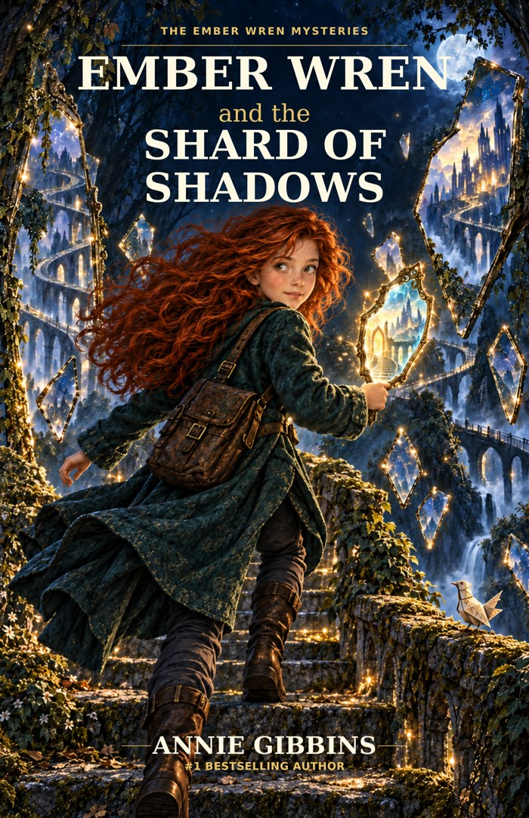
SPOILER NOTE
Read the novel first. This guide discusses discoveries and choices from throughout the story, including the ending.

Annie Gibbins · Satinbird Press · satinbirdpress.com

Welcome Back to Wetherwild
Book Three begins with a strange temptation: what if you could see a movement before it happened? At first, the shard seems to offer exactly what Ember has always wanted – enough warning to stop mistakes before anyone gets hurt.
But this story asks whether seeing a possibility is the same as knowing the future, and whether wanting to protect someone gives you the right to choose for them.
A SIMPLE BOOK-CLUB RULE
A strong discussion can end with more than one reasonable interpretation. Use the story to explain why you think what you think.

Quick Book Club Plan
Stage | What to do
1. Start | Each reader names one moment that made them nervous, surprised or uncertain.
2. Choose | Pick 4–6 discussion questions.
3. Dig deeper | Choose one theme: prediction, autonomy, helping, mistakes or uncertainty.
4. Create | Try one activity or one 'What Would You Do?' question.
5. Finish | Each reader shares one way Ember has changed since Book One.

About the Story
The shard left behind from the earlier mysteries begins showing movements just before they happen. Ember is fascinated by the possibility of preventing danger. But when she acts on a vision of Rowan falling, her attempt to rescue him becomes part of the problem.
With Mum, Rowan, Quill, Sable and Miss Bell, Ember investigates a larger apparatus connected to the shard. Mistress Vire can demonstrate apparently useful predictions, but the system hides other possibilities and eventually moves people against their will.
The final challenge is not simply stopping a machine. Ember has to learn when to act, when to ask, when to check and when to admit that she cannot see enough to decide for someone else.

Meet the Characters Again

Ember Wren
Ember still notices what others miss and wants to help quickly. Her new challenge is learning that a warning is not the same as certainty.
TALK ABOUT IT
Find one moment when Ember acts too quickly and one when she deliberately pauses.

Rowan Vale
Rowan is building a future around maps, study and Wayfinding. His plans belong to him, even when Ember cares deeply about him.
TALK ABOUT IT
Why does Rowan's independence matter to the story?

Mum
Mum investigates alongside Ember but has fears, evidence and choices of her own.
TALK ABOUT IT
Why is Mum's account of her own hand moving important?

Quill
The paper rook remains funny, unpredictable and unexpectedly useful.
TALK ABOUT IT
How does Quill's changed wing or ordinary shadow help the investigation?

Archivist Sable
Sable keeps records, compares accounts and accepts responsibility when evidence shows a fault.
TALK ABOUT IT
What does Sable do that makes their expertise trustworthy?

Miss Bell
Miss Bell turns strange events into practical tests and knows when skilled help is needed.
TALK ABOUT IT
How is Miss Bell's expertise different from Vire's use of knowledge?

Warden Hale
Hale gathers evidence and is willing to change the official record when better information appears.
TALK ABOUT IT
Why does changing the record matter?

Mistress Seraphine Vire
Vire believes preventing mistakes can justify increasing control over people's choices.
TALK ABOUT IT
Which parts of her argument sound reasonable, and where does it become dangerous?

Questions for Your Book Club
- What did you first think the moving shadow meant?
- Why is the idea of a warning before every mistake especially tempting for Ember?
- What evidence suggests the shard shows possibilities rather than one fixed future?
- Why does Ember's attempt to save Rowan go wrong?
- How does Rowan's account of the fall differ from Ember's understanding of it?
- Why is it important that Sable accepts responsibility for the unsafe landing as well as recording Ember's part?
- What does Ember learn from Miss Bell's practical tests?
- How can a demonstration show something true and still be misleading?
- What is important about the versions Vire does not show?
- Why does Mum's hand moving against her will change the nature of the problem?
- What is the difference between advice, warning and control?
- Why can 'the safest option' still be unfair?
- How does Rowan's work on maps show that he is building a future for himself?
- What does Ember need to accept when Rowan's plans do not include her?
- When does uncertainty become a strength rather than a weakness?
- Why does the group rely on ordinary tools, shadows and shared checks during the climax?
- What is important about the moment when Ember cannot see enough and chooses not to rush?
- Why does Ember correct the record when people blame the shard itself?
- What is the difference between a dangerous tool and a dangerous use of a tool?
- Why does Hale changing what he has written matter?
- How has Vire's idea of protection developed across the trilogy?
- What does the final kitchen-table scene show about Ember's growth?
- Do you think Ember would have made the same choices at the beginning of Book One? Why or why not?

The Possibility Challenge
Question | Discuss
What did we actually see? | Separate observation from explanation.
What else could happen? | Look for missing alternatives.
Who is affected? | Include the person whose future is being discussed.
What do we not know? | Name uncertainty instead of hiding it.
Whose choice is it? | Decide whether information gives permission to act.

BIG QUESTION
Can a warning be useful without becoming an instruction?

Themes Worth Talking About

Possibility and Prediction
Why is 'might happen' so different from 'will happen'?

Autonomy
When should someone be allowed to make a choice even if another person thinks they know the safer option?

Helping and Controlling
How can help become harmful if the helper stops listening?

Information and Power
Why does controlling what people see also influence what they choose?

Uncertainty
What changes when Ember becomes able to say, in effect, 'I do not know enough yet'?

Mistakes and Growth
Would a world without mistakes necessarily be a better world?

Evidence and Correction
Which characters are willing to update their conclusions when new evidence appears?

Choosing Your Future
Why is Rowan's future important even though it is not the main magical mystery?

What Would You Do?
WHAT WOULD YOU DO?
You see a possible accident before it happens, but you are not sure the image is complete. Do you act immediately or check first?

WHAT WOULD YOU DO?
A friend is making a choice you think may be a mistake. How can you help without taking over?

WHAT WOULD YOU DO?
Someone shows you a demonstration proving their system works, but you learn they chose which examples to show. What would you ask next?

WHAT WOULD YOU DO?
A safety system could stop people making some mistakes, but it would also make choices for them. Would you use it?

WHAT WOULD YOU DO?
You discover that your earlier intervention caused part of the harm you were trying to prevent. What should you do next?

Creative Activities
- Create three possible futures for the same scene. What small choice sends each version in a different direction?
- Design a warning system that informs people without taking away their choices. Include at least three safeguards.
- Draw Vire's demonstration twice: once as she presents it and once showing the missing alternatives.
- Create Rowan's map project. Mark which areas are confirmed, uncertain or deliberately left unfinished.
- Write a short incident report of Rowan's fall using Ember's account, Rowan's account and confirmed facts.
- Write a letter from end-of-trilogy Ember to the Ember who first found the eleven missing seconds.
- Design a book-club challenge using light and shadows, with no spoilers for anyone who has not yet read the book.

Mini Quiz
- What strange thing does the shard's shadow do at the beginning?
- Whose fall does Ember try to prevent?
- Who helps Ember test the shard in a practical workshop?
- What kind of work is Rowan interested in developing?
- What does Vire's apparatus show?
- What happens to Mum's hand that reveals the system can do more than warn?
- Who investigates Vire and later updates the written record?
- What ordinary visual clue helps the group understand the apparatus during the climax?
- Does Ember decide the shard itself is evil?
- What does Ember do differently by the final kitchen-table scene?
ANSWERS
1. It moves before the shard / changes before the object moves. 2. Rowan's. 3. Miss Bell. 4. Mapping / Wayfinding study and work. 5. Selected possible movements or rehearsals. 6. It moves against her will. 7. Warden Hale. 8. An ordinary shadow, including the wheel's shadow. 9. No. She distinguishes the object from how it was used. 10. She listens, keeps questions open and does not rush to control the answer.

Finish Your Book Club
- The moment when uncertainty mattered most was...
- The character who used information most responsibly was...
- The choice I would have made differently was...
- The strongest example of help becoming control was...
- The thing Ember has learned across the trilogy is...
- The question I am still thinking about is...

Looking Back Across the Trilogy
Book | Big question
The Key to Wetherwild | What if I am certain I am right?
The Crown of Echoes | What if an old answer no longer fits?
The Shard of Shadows | What if I think I know what will happen next?

SERIES QUESTION
How does Ember learn to stay curious without needing to control every answer?

More from Wetherwild
Free teacher packs and book club guides for all three books, plus a whole-trilogy guide.
Web: satinbirdpress.com → Ember Wren Email: hello@satinbirdpress.com Instagram: @emberwrenmysteries
Share your group’s feedback on the Reviews & Feedback page, or book Annie for a school or library visit, in person or online.
 Scan to book an author visit

Classroom and Book Club Use
This resource is designed for non-commercial use by families, libraries, schools and book clubs. Facilitators and educators may reproduce activity pages for participants in their own group. Commercial resale or republication requires written permission from Satinbird Press.
Ember Wren and the Shard of Shadows © Annie Gibbins. Book Club Discussion Guide © Satinbird Press.

