
THE EMBER WREN MYSTERIES · BOOK TWO
Ember Wren and the Crown of Echoes
Book Club Discussion Guide
For readers aged 8–12, families, libraries and school book clubs
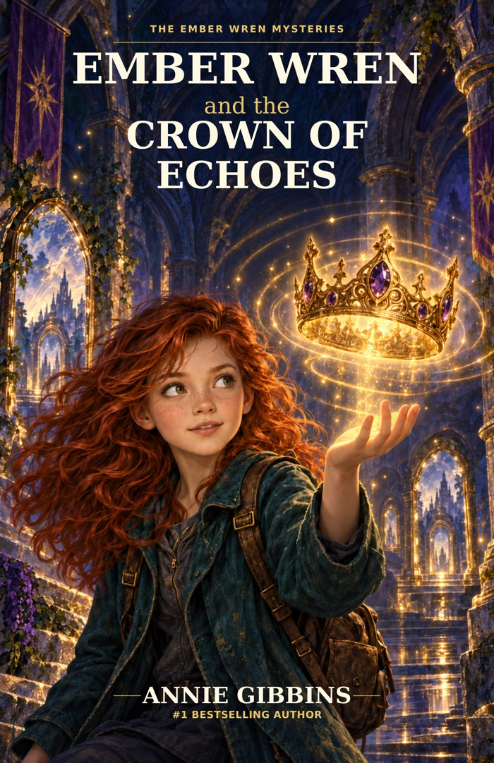
SPOILER NOTE
Read the novel first. This guide discusses discoveries and choices from throughout the story, including the ending.

Annie Gibbins · Satinbird Press · satinbirdpress.com

Welcome Back to Wetherwild
Book Two asks a different kind of mystery question. Instead of asking only what happened, it asks what should happen when an old answer no longer fits the person who gave it.
This guide is designed for young readers, families, librarians and school book clubs. Choose the questions that suit your group. You do not need to agree, but you should be able to point to the story when explaining your view.
A SIMPLE BOOK-CLUB RULE
Understanding why a character made a choice is not the same as deciding the choice was right.

Quick Book Club Plan
Stage | What to do
1. Start | Each reader names one moment that surprised them, frustrated them or made them rethink a character.
2. Choose | Pick 4–6 discussion questions.
3. Dig deeper | Choose one theme or one of the crown's five functions.
4. Create | Try one activity or 'What Would You Do?' question.
5. Finish | Each reader shares one thing they would like to ask Ember, Mum, Rowan or Vire.

About the Story
A voice from Nanna Violet's music box turns out to be Mum's own childhood voice. That discovery draws Ember, Mum, Rowan and Quill back into Wetherwild, where travellers are caught on routes that cannot properly finish.
The damaged Crown of Echoes was built around five functions: HEAR, KEEP, CARRY, ANSWER and RELEASE. Ember learns that the crown can preserve an old request long after the person who made it has changed their mind.
As the mystery deepens, Ember crosses an agreed stopping point to hear more of a recording, causing new danger. Mum must finally confront the way her own childhood answer was treated as permanent. In the climax, she chooses to let the crown's stored voices go so that the old holds can truly end.

Meet the Characters Again

Ember Wren
Ember is more careful than she was in Book One, but her need for answers can still outrun her willingness to stop.
TALK ABOUT IT
Where does Ember listen well in this book, and where does she listen only for the answer she wants?

Mum
Mum carries both affection for Violet and anger about not being heard when she changed her mind.
TALK ABOUT IT
Why is it important to keep Mum's childhood answer, later answer and adult choice separate?

Rowan Vale
Rowan is beginning to imagine a future beyond Hearthhollow while still caring deeply about his family.
TALK ABOUT IT
Find a moment when Rowan makes a choice Ember has to respect even if she would choose differently.

Quill
Quill remains funny, unpredictable and unexpectedly useful.
TALK ABOUT IT
Choose one funny moment and one useful action. What do they show about Quill's place in the group?

Miss Bell
Miss Bell uses models, tools, food and practical thinking to help the group understand the crown.
TALK ABOUT IT
Why is her kind of expertise different from Vire's?

Archivist Sable
Sable compares records with physical evidence and asks permission before preserving Mum's account.
TALK ABOUT IT
What does Sable do that shows careful listening?

Mistress Seraphine Vire
Vire can make dangerous situations safer, but repeatedly wants safety to depend on her control.
TALK ABOUT IT
Find evidence for both sides before deciding what you think of her.

Nanna Violet
Violet is heard through recordings and memories, but those recordings cannot make new choices or answer new questions.
TALK ABOUT IT
What does the ordinary conversation about the coat and conkers reveal that a dramatic magical message might not?

Questions for Your Book Club
- What was your first reaction when the voice from the music box turned out to be Mum's younger voice?
- Why does Mum find it difficult to tell Ember the whole story at once?
- Can Ember trust Mum and still question what Mum says? Use two scenes to explain your answer.
- Why are Nell, Tansy and Pip important to understanding what a failed release really means?
- How does Miss Bell's teaching frame help you understand HEAR, KEEP, CARRY, ANSWER and RELEASE?
- Why is ANSWER a separate function from HEAR?
- Why does Ember go beyond the agreed playback mark?
- What information about the danger does Ember already have when she makes that choice?
- How is explaining Ember's reason different from deciding that her action was right?
- Rowan tells Ember he needs to be able to believe her. What later action begins to rebuild that trust?
- Why does Mum's childhood wish to stay in Wetherwild not settle what should happen to her later?
- What is the difference between choosing to wait and being unable to leave?
- What does the ordinary recorded conversation between Mum and Violet add to the story?
- Why can't the group simply save the private recording and release everything else?
- How does Vire's help during dangerous crossings complicate the way you judge her?
- Why do the rescuers release individual routes one by one rather than declaring one universal solution?
- What does Mum give up when she empties the crown?
- Why is it important that Ember lets Mum make the final choice?
- Does Violet's apology erase the harm caused by not listening sooner? Why or why not?
- What does the silent crown mean at the end of the story?
- How has Rowan changed since Book One?
- What new question does the moving shard set up for Book Three?

The Crown Challenge
The crown works through five functions: HEAR. KEEP. CARRY. ANSWER. RELEASE.
Function | Book-club challenge
HEAR | Find a moment when someone hears words but does not fully listen.
KEEP | Find something preserved because it matters. Does keeping it help or hurt?
CARRY | Find a choice whose consequences travel beyond the person who first made it.
ANSWER | Find a moment when a new answer should matter more than an old one.
RELEASE | Find something that has to end before the characters can move forward.

BIG QUESTION
Can a system truly listen if it can HEAR and KEEP but does not allow ANSWER and RELEASE?

Themes Worth Talking About

Changing Your Mind
Why should a sincere answer from the past be allowed to change later?

Trust and Telling the Truth
Compare Ember wanting answers from Mum with Rowan needing to know whether he can trust Ember.

Listening and Boundaries
When does curiosity become a problem because Ember ignores an agreed stop?

Safety and Choice
What is useful about Vire's concern for safety, and when does it become control?

Memory and Grief
What can a recording preserve? What can it never replace?

Family Love and Imperfection
How can Mum love Violet and still be angry about what happened?

Release
Why does letting go not mean that something never mattered?

Identity After Crisis
What does Rowan begin choosing for himself now that Hearthhollow is no longer frozen?

What Would You Do?
WHAT WOULD YOU DO?
You discover a recording from your own childhood that someone else has been keeping. Who should decide whether it is played?

WHAT WOULD YOU DO?
Someone once said yes to a plan but now says no. Which answer should guide what happens next?

WHAT WOULD YOU DO?
You are asked to stop a recording at a certain point, but you think three more words could solve the mystery. Do you keep going?

WHAT WOULD YOU DO?
You can preserve the voice of someone you miss, but doing so will keep other people trapped. What matters most?

WHAT WOULD YOU DO?
A person offers real safety, but only if they control when everyone else may leave. Would you accept the help?

Creative Activities
- Draw the crown and label HEAR, KEEP, CARRY, ANSWER and RELEASE. Add one moment from the story beside each function.
- Create a looping Wetherwild route and invent the request that caused it. Then write the new answer that should release it.
- Write a short conversation between young Mum and adult Mum.
- Design a magical object that stores memories but must include a safe release rule.
- Create a relationship web for Ember, Mum, Rowan, Vire, Sable and Violet. Label each line with an action such as 'asks', 'withholds', 'trusts', 'questions' or 'releases'.
- Plan a book-club snack or activity inspired by crowns, echoes, looping roads or conkers.

Mini Quiz
- Whose childhood voice comes from the music box?
- Name the crown's five functions.
- Which family is caught in the delivery loop?
- Who uses a teaching frame to demonstrate how a working crown lets go?
- What does Ember do that crosses an agreed stopping point?
- Who helps compare official records with physical evidence?
- What does young Mum first want to do in Wetherwild?
- What does she later ask to do?
- What precious thing does Mum choose to lose at the climax?
- What object begins behaving strangely at the end?
ANSWERS
1. Mum's. 2. HEAR, KEEP, CARRY, ANSWER, RELEASE. 3. Nell, Tansy and baby Pip. 4. Miss Bell. 5. She turns the playback beyond the agreed mark. 6. Sable. 7. Stay. 8. Leave. 9. The stored voices, including Violet's recorded voice. 10. The shard / its shadow.

Finish Your Book Club
- The character I understand differently now is...
- The choice I would most like to discuss again is...
- The moment when someone was not really listened to was...
- The thing I think the crown represents is...
- The part of the ending that felt most hopeful was...
- The question I am carrying into Book Three is...

Continue the Adventure
The mystery continues in Ember Wren and the Shard of Shadows.
A QUESTION TO CARRY INTO BOOK THREE
If you could see what might happen next, would that give you the right to stop someone from choosing for themselves?

Visit satinbirdpress.com for more Ember Wren resources, teacher packs and reading guides.
More from Wetherwild
Free teacher packs and book club guides for all three books, plus a whole-trilogy guide.
Web: satinbirdpress.com → Ember Wren Email: hello@satinbirdpress.com Instagram: @emberwrenmysteries
Share your group’s feedback on the Reviews & Feedback page, or book Annie for a school or library visit, in person or online.
 Scan to book an author visit

Classroom and Book Club Use
This resource is designed for non-commercial use by families, libraries, schools and book clubs. Facilitators and educators may reproduce activity pages for participants in their own group. Commercial resale or republication requires written permission from Satinbird Press.
Ember Wren and the Crown of Echoes © Annie Gibbins. Book Club Discussion Guide © Satinbird Press.

