
THE EMBER WREN MYSTERIES · BOOK ONE
Ember Wren and the Key to Wetherwild
Book Club Discussion Guide
For readers aged 8–12, families, libraries and school book clubs
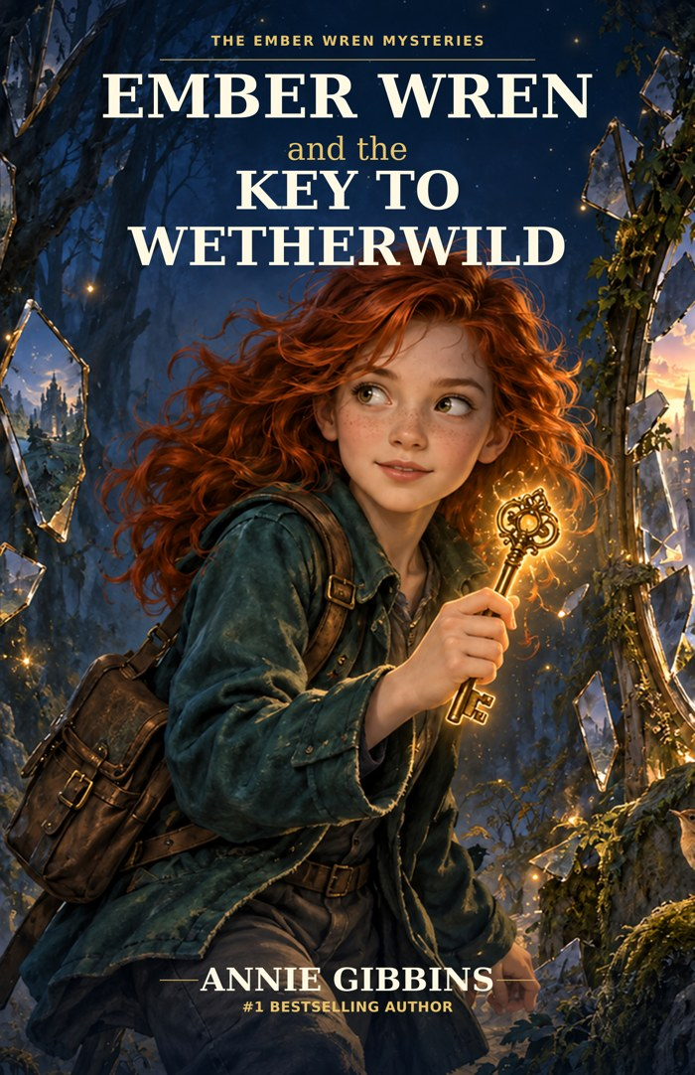
SPOILER NOTE
Read the novel first. This guide discusses discoveries and choices from throughout the story, including the ending.

Annie Gibbins · Satinbird Press · satinbirdpress.com

Welcome to Wetherwild
A good mystery does not end when the last page turns. A book club gives readers the chance to revisit clues, disagree with a character, notice something new and discover that another reader may have understood the same scene differently.
This guide is designed for young readers, families, librarians and school book clubs. Use every section or choose only the questions and activities that suit your group.
A SIMPLE BOOK-CLUB RULE
You do not have to agree. You do need to give other readers time to explain what in the story made them think that.

Quick Book Club Plan
Stage | What to do
1. Start | Each person names one moment that made them laugh, worry, wonder or change their mind.
2. Choose | Pick 4–6 discussion questions rather than trying to answer everything.
3. Dig deeper | Choose one theme or character question.
4. Create | Try one activity together or separately.
5. Finish | Each reader shares one question they are still thinking about.

About the Story
Eleven-year-old Ember Wren notices something impossible: three clocks lose exactly eleven seconds at the same time. Her investigation leads from Nanna Violet's house through a living reflection and into Wetherwild, where roads rearrange themselves, maps have opinions and a town called Hearthhollow has been frozen for seven years.
With apprentice Wayfinder Rowan Vale and the folded-paper rook Quill, Ember tries to discover what happened. But the deeper she goes, the more complicated the truth becomes. Nanna Violet and Mistress Vire both made choices that shaped Hearthhollow's fate, and Ember must decide whether solving a puzzle is enough when other people have to live with the answer.

Meet the Characters Again

Ember Wren
Observant, funny, determined and sometimes much too certain once she thinks she has solved something.
TALK ABOUT IT
Find an early decision and a later decision that show how Ember's thinking changes.

Rowan Vale
A young Wayfinder whose family is trapped in Hearthhollow.
TALK ABOUT IT
Choose a moment when Rowan's hopes make Ember's puzzle feel personal rather than abstract.

Quill
A folded-paper rook with a complicated relationship with maps, ownership and instructions.
TALK ABOUT IT
Find one scene where Quill makes you laugh and one where Quill's actions seriously matter.

Nanna Violet
Ember's beloved grandmother, whose clues and past choices shape the mystery.
TALK ABOUT IT
What does Ember learn that makes her picture of Violet more complicated?

Mum
Ember's emotional connection to home, grief and a family history Ember does not yet understand.
TALK ABOUT IT
What small actions show Mum's care even when Ember keeps things from her?

Mistress Seraphine Vire
A powerful figure who believes control can prevent terrible consequences.
TALK ABOUT IT
Choose one claim Vire makes. What supports it, what makes you doubt it and what is missing?

Questions for Your Book Club
- The story begins with eleven missing seconds. What made you want to keep reading: the impossible event, Ember's reaction, the family situation or something else?
- Nanna warns Ember not to solve the mystery alone. Why is that advice difficult for Ember to follow? Does your view of her decision change by the end?
- When does Rowan become someone Ember can genuinely rely on? Choose a particular action rather than simply calling him brave or kind.
- Did you solve any clue before Ember, at the same time or afterwards? What information made the solution possible?
- Which joke, comparison or observation best captures Ember's personality?
- Can you understand a character's reasons and still disagree with the choice they make? Use an example.
- Why is the borrowed minute in Hearthhollow both wonderful and painful?
- How does losing the remembered sound of Nanna Violet's laugh change the cost of Ember's decision?
- Why are two conflicting records more useful once Ember notices the same information has been removed from both?
- What makes the Unwritten frightening in a different way from an ordinary fantasy monster?
- Why does Quill's sacrifice matter emotionally as well as magically?
- What does Ember learn about Violet that is hardest for her to accept?
- Why is Vire more interesting than a villain who simply wants to hurt people?
- What is important about Vire finally using the word 'I' when describing what happened?
- Why does Ember reject becoming the permanent Keeper?
- What does the final solution say about sharing truth and responsibility?
- What does the ending resolve for Ember? What new mystery does Mum's final revelation create?
- If you could ask one character one question after the final page, who would you choose and what would you ask?

Themes Worth Talking About

Curiosity and Certainty
Find a moment when Ember thinks she knows the answer. What happens when she tests that idea? What is the difference between confidence and refusing to reconsider?

Friendship and Asking for Help
Choose a problem Ember could not have solved in the same way on her own. What does another character contribute?

Truth and Missing Information
Why does the story care so much about what has been deliberately removed rather than simply forgotten?

Good Intentions and Consequences
Choose Ember, Violet or Vire. What did the character hope to achieve? What consequences followed anyway?

Grief, Memory and Love
How can Ember keep loving Violet after learning that Violet made serious mistakes?

Choice and Consent
Which decisions belong to one person, and which should include everyone who will live with the consequences?

Leadership and Responsibility
What is the difference between taking responsibility and deciding everything yourself?

Sharing
Why do you think SHARE is the final word in the Wren pattern?

The Wren Challenge
Nanna Violet's seven words are: SEEK. QUESTION. TEST. TURN. DOUBT. CHOOSE. SHARE.
Word | Find a moment when Ember...
SEEK | looks closely for evidence.
QUESTION | asks something others have accepted.
TEST | checks an idea rather than assuming it is true.
TURN | looks at the problem from another angle.
DOUBT | realises she may be wrong.
CHOOSE | makes a decision with consequences.
SHARE | includes others instead of acting alone.

BOOK CLUB CHALLENGE
Which word do you think Ember is best at at the beginning? Which one does she most need to learn?

What Would You Do?
WHAT WOULD YOU DO?
You find a warning telling you not to solve a mystery alone, but you are afraid an adult will dismiss you. What do you do next?

WHAT WOULD YOU DO?
You can wake a frozen town for one minute, but the price is a precious memory. Would you accept?

WHAT WOULD YOU DO?
You discover that someone you love made an important mistake years ago. Does that change how you feel about them?

WHAT WOULD YOU DO?
A leader says a harmful decision was 'necessary'. What questions would you ask before accepting that explanation?

WHAT WOULD YOU DO?
You are offered a heroic solution that makes you carry the whole burden alone. Would you take it, or look for another way?

Creative Activities
- Design a new Wetherwild location where one ordinary rule works differently. Give it a name, a danger and a clue that reveals how it really works.
- Create a magical object with a useful purpose, a clear rule and an unexpected cost.
- Draw an evidence board for the Hearthhollow mystery. Mark clues as CONFIRMED, POSSIBLE, DISPUTED or UNKNOWN.
- Write a postcard from Rowan to Ember after she returns home.
- Write a short scene from Quill's point of view. You may decide whether Quill thinks like a person, a map, a bird or something else entirely.
- Create a new seven-word thinking pattern for a different kind of mystery.
- Design a book-club snack, game or decoration inspired by clocks, maps, wrens or reflections.

Mini Quiz
1. What unusual thing happens to the clocks at the beginning?
2. What kind of creature is Quill?
3. What has happened to Hearthhollow?
4. What personal thing does Ember give up for the borrowed minute?
5. Who is the librarian of the Library of Lost Knowledge?
6. What threatens truth, records and identity in Wetherwild?
7. What two magical keys are central to the final mystery?
8. What does Ember refuse to become?
9. What changes on Ember's palm by the end?
10. What does Mum reveal that changes Ember's understanding of her family?
ANSWERS
1. They lose eleven seconds. 2. A folded-paper rook. 3. It has been frozen in time for seven years. 4. The remembered sound of Nanna Violet's laugh. 5. Morrow. 6. The Unwritten. 7. The green and silver keys. 8. The permanent Keeper / sole permanent witness. 9. The key becomes seven green points like a constellation. 10. Mum has also experienced the mysterious reflection / has been to Wetherwild.

Finish Your Book Club
Take turns completing one sentence:
- The moment I keep thinking about is...
- The character I understand differently now is...
- The choice I most disagreed with was...
- The clue I liked best was...
- The question I still have is...
- If I went to Wetherwild, I would...

Continue the Adventure
The mystery continues in Ember Wren and the Crown of Echoes.
A QUESTION TO CARRY INTO BOOK TWO
What happens when an old choice keeps controlling someone long after they have changed?

Visit satinbirdpress.com for more Ember Wren resources, teacher packs and reading guides.
More from Wetherwild
Free teacher packs and book club guides for all three books, plus a whole-trilogy guide.
Web: satinbirdpress.com → Ember Wren Email: hello@satinbirdpress.com Instagram: @emberwrenmysteries
Share your group’s feedback on the Reviews & Feedback page, or book Annie for a school or library visit, in person or online.
 Scan to book an author visit

Classroom and Book Club Use
This resource is designed for non-commercial use by families, libraries, schools and book clubs. Facilitators and educators may reproduce activity pages for participants in their own group. Commercial resale or republication requires written permission from Satinbird Press.
Ember Wren and the Key to Wetherwild © Annie Gibbins. Book Club Discussion Guide © Satinbird Press.

